SIMATS ENGINEERING Name:P.Ranjithkumar
ASSESSMENT TOOL 1 Reg.no:192411119

COURSE NAME: INTERNET PROGRAMMING
COURSE CODE: CSA4304

COURSE OUTCOME COVERED
CO-2 : Apply CSS layout and styling techniques to create visually appealing and responsive web interfaces, and use JavaScript to enable interactive client-side behavior. (L3)
Assessment Tool : Integrated Experiments
Weightage: 40%

QUESTIONS: Total Marks: 30

Code of Conduct:
I P.Ranjithkumar (192411119) (Name / Reg No) certify that this submission is my
original work and that I have adhered to the guidelines specified for this assessment.
I understand that any violation of academic integrity rules will result in disciplinary
action.

Signature of the student:

EXPERIMENT 1: RESPONSIVE LAYOUT DESIGN
To analyze why a retail website fails on mobile and tablet devices and develop a responsive layout using CSS Flexbox, Grid and media queries. The layout includes a header, navigation bar, product content area and footer with consistent spacing and alignment.

Problem Statement
A retail website is not responsive across mobile and tablet devices. Content becomes misaligned, navigation links overflow, product cards become too narrow, and spacing differs between sections. The solution is to use flexible layout rules and breakpoints instead of fixed desktop-only dimensions.

(a) Analysis of Possible Reasons
Fixed pixel widths: How it causes the problem – A 1200px container cannot fit a narrow phone screen.; Recommended correction – Use width: 100%, max-width and flexible columns.
No viewport meta tag: How it causes the problem – Mobile browsers may render a page at a virtual desktop width.; Recommended correction – Add the viewport meta tag in the HTML head.
Fixed navigation row: How it causes the problem – Links overflow or become cramped on small screens.; Recommended correction – Allow wrapping or switch to a vertical menu.
Absolute positioning used for major sections: How it causes the problem – Elements do not move naturally when text wraps or viewport changes.; Recommended correction – Use Flexbox/Grid for page structure; reserve absolute positioning for small overlays.
Large fixed images: How it causes the problem – Images stretch beyond cards or cause horizontal scrolling.; Recommended correction – Use max-width: 100% and object-fit.
Inconsistent margins and padding: How it causes the problem – Sections look uneven and crowded.; Recommended correction – Use a spacing scale and CSS variables.
No media queries: How it causes the problem – The same desktop layout is forced on all devices.; Recommended correction – Add breakpoints for mobile and tablet.
Content has unbreakable text: How it causes the problem – Long product names or URLs widen the page.; Recommended correction – Use overflow-wrap: anywhere where appropriate.

(b) Responsive Layout Design
The example uses Flexbox for the header and navigation, and CSS Grid for product cards. Grid automatically distributes cards according to the available width. The layout follows a mobile-first approach: one column on a narrow screen, two columns on tablets and three or four columns on larger screens.

Layout Architecture Diagram
Desktop / wide tablet layout
┌──────────────────────────────────────────────────────────────┐
│ HEADER: Brand Search │
├──────────────────────────────────────────────────────────────┤
│ NAVIGATION: Home | Categories | Deals | Contact │
├──────────────────────────────────────────────────────────────┤
│ MAIN CONTENT │
│ ┌─────────────┐ ┌─────────────┐ ┌─────────────┐ │
│ │ Product 1 │ │ Product 2 │ │ Product 3 │ ... │
│ └─────────────┘ └─────────────┘ └─────────────┘ │
├──────────────────────────────────────────────────────────────┤
│ FOOTER: Help | Returns | Privacy | Copyright │
└──────────────────────────────────────────────────────────────┘

Responsive behaviour
Mobile: Typical viewport – 320–600px; Product grid – 1 column; Navigation – Wraps to multiple lines
Tablet: Typical viewport – 601–900px; Product grid – 2 columns; Navigation – Horizontal if space permits
Desktop: Typical viewport – 901px and above; Product grid – 3–4 columns; Navigation – Single horizontal row

(c) Complete Runnable Code
Create a folder named experiment1-responsive and add index.html, style.css and script.js. The JavaScript only updates the year in the footer; the responsive layout is handled by CSS.

File 1: index.html
<!DOCTYPE html>
<html lang="en">
<head>
<meta charset="UTF-8">
<meta name="viewport" content="width=device-width, initial-scale=1.0">
<title>ShopSmart - Responsive Retail Store</title>
<link rel="stylesheet" href="style.css">
</head>
<body>
<header class="site-header">
<a class="brand" href="#" aria-label="ShopSmart home">ShopSmart</a>
<form class="search" role="search">
<label class="visually-hidden" for="searchBox">Search products</label>
<input id="searchBox" type="search" placeholder="Search products">
<button type="submit">Search</button>
</form>
</header>
<nav class="main-nav" aria-label="Main navigation">
<a href="#home">Home</a>
<a href="#products">Products</a>
<a href="#offers">Offers</a>
<a href="#support">Customer Support</a>
</nav>
<main id="home" class="page-container">
<section class="intro">
<p class="eyebrow">SMART SHOPPING, EVERYWHERE</p>
<h1>Find products you will love</h1>
<p>Explore useful products at friendly prices, on any device.</p>
</section>
<section id="products" aria-labelledby="productsHeading">
<div class="section-heading">
<h2 id="productsHeading">Featured products</h2>
<p>Popular picks for this week</p>
</div>
<div class="product-grid">
<article class="product-card">
<div class="product-art art-blue" aria-hidden="true">🎧</div>
<div class="product-info"><h3>Wireless Headphones</h3>
<p>Comfortable sound for work and travel.</p><strong>₹1,499</strong>
<button type="button">View product</button></div>
</article>
<article class="product-card">
<div class="product-art art-yellow" aria-hidden="true">⌚</div>
<div class="product-info"><h3>Smart Watch</h3>
<p>Track daily activity and notifications.</p><strong>₹2,299</strong>
<button type="button">View product</button></div>
</article>
<article class="product-card">
<div class="product-art art-green" aria-hidden="true">🎒</div>
<div class="product-info"><h3>Everyday Backpack</h3>
<p>A practical bag for college and travel.</p><strong>₹899</strong>
<button type="button">View product</button></div>
</article>
<article class="product-card" id="offers">
<div class="product-art art-pink" aria-hidden="true">🔊</div>
<div class="product-info"><h3>Portable Speaker</h3>
<p>Small size with room-filling sound.</p><strong>₹1,099</strong>
<button type="button">View product</button></div>
</article>
</div>
</section>
</main>
<footer id="support" class="site-footer">
<p>Help Centre · Returns · Privacy Policy</p>
<p>© <span id="year"></span> ShopSmart</p>
</footer>
<script src="script.js"></script>
</body>
</html>

File 2: style.css
/* Mobile-first responsive styles */
:root {
--ink: #172033;
--muted: #5d6678;
--brand: #174ea6;
--brand-dark: #103b7d;
--surface: #ffffff;
--page: #f4f7fb;
--line: #dce3ee;
--space-1: 0.5rem;
--space-2: 1rem;
--space-3: 1.5rem;
--space-4: 2rem;
}
* { box-sizing: border-box; }
html { scroll-behavior: smooth; }
body {
margin: 0;
color: var(--ink);
background: var(--page);
font-family: Arial, Helvetica, sans-serif;
line-height: 1.6;
}
a { color: inherit; }
.site-header {
display: flex;
flex-direction: column;
align-items: stretch;
gap: var(--space-2);
padding: var(--space-2);
background: var(--surface);
border-bottom: 1px solid var(--line);
}
.brand {
color: var(--brand);
font-size: 1.5rem;
font-weight: 800;
text-decoration: none;
}
.search { display: flex; gap: var(--space-1); }
.search input {
min-width: 0;
flex: 1;
padding: 0.7rem;
border: 1px solid #aab5c5;
border-radius: 0.5rem;
font: inherit;
}
button {
padding: 0.65rem 0.9rem;
border: 0;
border-radius: 0.5rem;
background: var(--brand);
color: white;
font: inherit;
cursor: pointer;
}
button:hover, button:focus-visible { background: var(--brand-dark); }
button:focus-visible, a:focus-visible, input:focus-visible {
outline: 3px solid #f2b705;
outline-offset: 2px;
}
.main-nav {
display: flex;
flex-wrap: wrap;
gap: 0.25rem;
padding: 0.5rem 1rem;
background: #e6edf8;
}
.main-nav a {
padding: 0.45rem 0.75rem;
border-radius: 0.35rem;
text-decoration: none;
font-weight: 600;
}
.main-nav a:hover { background: white; }
.page-container { width: min(100% - 2rem, 1180px); margin-inline: auto; }
.intro { padding: 2rem 0 1.5rem; }
.eyebrow { color: var(--brand); font-size: 0.8rem; font-weight: 800; letter-spacing: 0.08em; }
h1 { margin: 0.2rem 0 0.5rem; font-size: clamp(1.7rem, 5vw, 2.8rem); line-height: 1.15; }
.intro p:last-child, .section-heading p { color: var(--muted); }
.section-heading {
display: flex;
flex-direction: column;
gap: 0.25rem;
margin: 1rem 0;
}
.section-heading h2, .section-heading p { margin: 0; }
.product-grid {
display: grid;
grid-template-columns: 1fr;
gap: var(--space-2);
padding-bottom: var(--space-4);
}
.product-card {
display: flex;
flex-direction: column;
min-width: 0;
overflow: hidden;
background: var(--surface);
border: 1px solid var(--line);
border-radius: 0.85rem;
box-shadow: 0 3px 12px rgb(25 45 80 / 7%);
}
.product-art {
display: grid;
min-height: 130px;
place-items: center;
font-size: 3.5rem;
}
.art-blue { background: #dceaff; }
.art-yellow { background: #fff1c9; }
.art-green { background: #d9f4e5; }
.art-pink { background: #fbe0ec; }
.product-info { display: flex; flex: 1; flex-direction: column; align-items: flex-start; padding: 1rem; }
.product-info h3 { margin: 0 0 0.3rem; overflow-wrap: anywhere; }
.product-info p { margin: 0 0 0.8rem; color: var(--muted); }
.product-info strong { margin-top: auto; margin-bottom: 0.8rem; font-size: 1.1rem; }
.site-footer { padding: 1.25rem; text-align: center; color: white; background: #172033; }
.site-footer p { margin: 0.25rem; }
.visually-hidden {
position: absolute; width: 1px; height: 1px; padding: 0; margin: -1px;
overflow: hidden; clip: rect(0, 0, 0, 0); white-space: nowrap; border: 0;
}
/* Tablet */
@media (min-width: 600px) {
.site-header { flex-direction: row; align-items: center; justify-content: space-between; }
.search { width: min(55%, 480px); }
.section-heading { flex-direction: row; align-items: baseline; justify-content: space-between; }
.product-grid { grid-template-columns: repeat(2, minmax(0, 1fr)); gap: 1.25rem; }
}
/* Desktop */
@media (min-width: 950px) {
.site-header { padding: 1rem max(1.5rem, calc((100% - 1180px) / 2)); }
.main-nav { padding-inline: max(1.5rem, calc((100% - 1180px) / 2)); gap: 0.75rem; }
.product-grid { grid-template-columns: repeat(4, minmax(0, 1fr)); gap: 1.5rem; }
.product-art { min-height: 160px; }
}
/* Reduced motion preference */
@media (prefers-reduced-motion: reduce) {
html { scroll-behavior: auto; }
}

File 3: script.js
document.addEventListener("DOMContentLoaded", () => {
document.getElementById("year").textContent = new Date().getFullYear();
const searchForm = document.querySelector(".search");
searchForm.addEventListener("submit", (event) => {
event.preventDefault();
const query = document.getElementById("searchBox").value.trim();
if (query) {
alert(`Demo search: "${query}". Connect this form to a product search service.`);
} else {
document.getElementById("searchBox").focus();
}
});
});

(d) Spacing, Alignment and Distribution
Consistent spacing scale: Implementation – CSS variables such as --space-1 and --space-2; Benefit – Repeated gaps feel deliberate and consistent.
Flexbox alignment: Implementation – align-items and justify-content in header; Benefit – Brand and search form align without fixed positioning.
Grid distribution: Implementation – repeat(2, minmax(0, 1fr)); Benefit – Equal columns and predictable card widths.
Responsive container: Implementation – width: min(100% - 2rem, 1180px); Benefit – Adds side breathing room and limits very wide lines.
Box sizing: Implementation – box-sizing: border-box; Benefit – Padding and border are included in declared dimensions.
Fluid typography: Implementation – clamp() for the main heading; Benefit – Text scales smoothly across screen sizes.
Overflow prevention: Implementation – min-width: 0 and overflow-wrap: anywhere; Benefit – Long text is less likely to force horizontal scrolling.

(e) Evaluation and Further Improvements
320px mobile width: Expected result – One product card per row; no horizontal scrollbar.; Status to record – Pass / Fail
390px mobile width: Expected result – Header search fits; navigation wraps if needed.; Status to record – Pass / Fail
768px tablet width: Expected result – Two product columns with even gaps.; Status to record – Pass / Fail
1280px desktop width: Expected result – Four cards per row and centered content.; Status to record – Pass / Fail
Keyboard navigation: Expected result – Links, search and buttons show visible focus.; Status to record – Pass / Fail
Zoom to 200%: Expected result – Text and controls remain usable.; Status to record – Pass / Fail
Evaluation: The layout is responsive because it uses a mobile-first grid, flexible header and navigation, relative widths, and breakpoints. It should be verified on real devices and in browser Developer Tools rather than assuming the CSS works in every browser.
Use real product images with descriptive alt text when replacing the emoji placeholders.
Add functional search, product detail routes, and cart behaviour if this becomes a real store.
Test accessibility contrast, keyboard navigation, zoom and screen-reader labels.
Use performance-optimized image formats and lazy loading for images below the fold.
Consider container queries if individual components must adapt to their own container rather than the whole viewport.

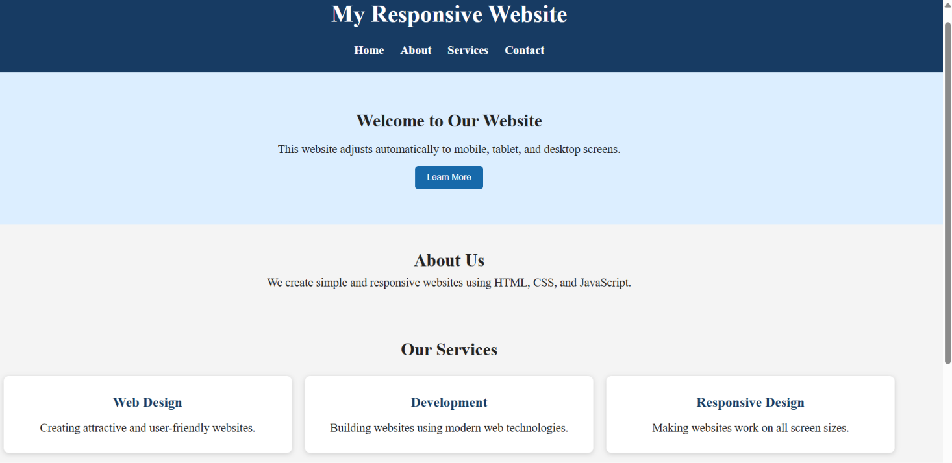

EXPERIMENT 2: FORM VALIDATION USING JAVASCRIPT
To build a registration form that checks email and phone number inputs using HTML attributes and JavaScript regular expressions, displays real-time error messages, and prevents submission when data is invalid.

Problem Statement
A registration form accepts incorrect email addresses and phone numbers. Incorrect data can lead to failed communication, duplicate records, account recovery problems and poor user experience. Validation should provide immediate feedback and must be repeated on the server before saving data.

(a) Analysis of Existing Validation Issues
No validation: Example – Input is blank but submitted.; Impact – Missing contact details.; Solution – Use required and JavaScript checks.
Only checks for @: Example – abc@ is accepted.; Impact – Malformed address passes.; Solution – Use a practical pattern and browser type=email.
Phone accepts any text: Example – abcdefghij passes.; Impact – Phone field is unusable.; Solution – Restrict allowed characters and validate digit count.
Error only after submit: Example – User discovers errors late.; Impact – More corrections and frustration.; Solution – Validate on input and blur.
Error message is unclear: Example – “Invalid” appears with no explanation.; Impact – User cannot fix the field easily.; Solution – Explain the required format beside the field.
No server validation: Example – Client checks can be bypassed.; Impact – Untrusted data may be stored.; Solution – Validate on server and normalize input.
Accessibility omitted: Example – Error is not announced to assistive technology.; Impact – Some users miss feedback.; Solution – Use aria-describedby and aria-live.

(b) HTML Input Design
The email field uses type=email and autocomplete=email. The phone field uses type=tel, inputmode=tel and autocomplete=tel. The browser attributes improve usability, while JavaScript provides the specified custom checks.

Validation Flow Diagram
Registration validation flow
┌───────────────────────┐
│ User types email/phone│
└───────────┬───────────┘
↓
┌────────────────────────┐
│ HTML constraints + JS │
│ regular-expression test│
└───────────┬────────────┘
↓
┌────┴─────┐
│ Valid? │
└──┬────┬──┘
Yes No
↓ ↓
┌──────────┐ ┌─────────────────┐
│ Clear │ │ Show field error│
│ message │ │ and block submit│
└────┬─────┘ └─────────────────┘
↓
┌────────────────────────┐
│ Submit valid form demo │
└────────────────────────┘

(c) Complete Runnable Code
Create a folder named experiment2-validation and add index.html, style.css and script.js.

File 1: index.html
<!DOCTYPE html>
<html lang="en">
<head>
<meta charset="UTF-8">
<meta name="viewport" content="width=device-width, initial-scale=1.0">
<title>Registration Form Validation</title>
<link rel="stylesheet" href="style.css">
<script src="script.js" defer></script>
</head>
<body>
<main class="form-card">
<h1>Create an account</h1>
<p class="intro">Enter your contact details. Fields marked * are required.</p>
<form id="registrationForm" novalidate>
<div class="field">
<label for="fullName">Full name *</label>
<input id="fullName" name="fullName" type="text"
autocomplete="name" required minlength="2">
<small class="error" id="nameError" aria-live="polite"></small>
</div>
<div class="field">
<label for="email">Email address *</label>
<input id="email" name="email" type="email"
autocomplete="email" required
aria-describedby="emailHint emailError">
<small class="hint" id="emailHint">Example: student@example.com</small>
<small class="error" id="emailError" aria-live="polite"></small>
</div>
<div class="field">
<label for="phone">Phone number *</label>
<input id="phone" name="phone" type="tel"
inputmode="tel" autocomplete="tel" required
placeholder="9876543210"
aria-describedby="phoneHint phoneError">
<small class="hint" id="phoneHint">Enter 10 digits, optionally with +91 or spaces.</small>
<small class="error" id="phoneError" aria-live="polite"></small>
</div>
<button type="submit">Register</button>
<p id="formMessage" role="status" aria-live="polite"></p>
</form>
</main>
</body>
</html>

File 2: style.css
* { box-sizing: border-box; }
body {
margin: 0;
min-height: 100vh;
display: grid;
place-items: center;
padding: 1rem;
background: #f1f5fb;
color: #1d2939;
font-family: Arial, Helvetica, sans-serif;
line-height: 1.5;
}
.form-card {
width: min(100%, 480px);
padding: clamp(1.25rem, 4vw, 2rem);
background: #fff;
border: 1px solid #d8e0ec;
border-radius: 1rem;
box-shadow: 0 8px 28px rgb(20 40 70 / 9%);
}
h1 { margin: 0 0 0.25rem; font-size: 1.8rem; }
.intro, .hint { color: #596579; }
.intro { margin-top: 0; margin-bottom: 1.5rem; }
.field { display: flex; flex-direction: column; gap: 0.35rem; margin-bottom: 1rem; }
label { font-weight: 700; }
input {
width: 100%;
padding: 0.75rem;
border: 1px solid #aab6c8;
border-radius: 0.45rem;
font: inherit;
}
input:focus-visible, button:focus-visible {
outline: 3px solid #f2b705;
outline-offset: 2px;
}
input[aria-invalid="true"] { border-color: #b42318; }
.hint, .error { font-size: 0.88rem; }
.error { min-height: 0; color: #b42318; font-weight: 600; }
button {
width: 100%;
padding: 0.8rem;
border: 0;
border-radius: 0.45rem;
color: #fff;
background: #174ea6;
font: inherit;
font-weight: 700;
cursor: pointer;
}
button:hover { background: #103b7d; }
#formMessage { margin-bottom: 0; font-weight: 700; }
#formMessage.success { color: #137547; }
#formMessage.failure { color: #b42318; }

File 3: script.js
const form = document.getElementById("registrationForm");
const nameInput = document.getElementById("fullName");
const emailInput = document.getElementById("email");
const phoneInput = document.getElementById("phone");
const formMessage = document.getElementById("formMessage");
/*
Email pattern: practical front-end check, not a complete implementation
of every valid email format. The server should perform authoritative checks.
*/
const emailPattern = /^[^\s@]+@[^\s@]+\.[^\s@]{2,}$/;
/*
Phone policy for this demo:
- accept 10 digits, or 91 followed by 10 digits
- allow spaces, hyphens, parentheses and an optional leading +
- after removing formatting, require 10 digits or 12 digits starting 91
*/
function normalizePhone(value) {
return value.replace(/[\s()-]/g, "");
}
function isValidPhone(value) {
const normalized = normalizePhone(value);
if (!/^\+?\d+$/.test(normalized)) return false;
const digits = normalized.startsWith("+")
? normalized.slice(1)
: normalized;
return /^\d{10}$/.test(digits) || /^91\d{10}$/.test(digits);
}
function showError(input, errorId, message) {
const error = document.getElementById(errorId);
error.textContent = message;
input.setAttribute("aria-invalid", message ? "true" : "false");
return message === "";
}
function validateName() {
const value = nameInput.value.trim();
if (value.length < 2) {
return showError(nameInput, "nameError", "Enter at least 2 characters.");
}
return showError(nameInput, "nameError", "");
}
function validateEmail() {
const value = emailInput.value.trim();
if (!value) return showError(emailInput, "emailError", "Email is required.");
if (!emailPattern.test(value)) {
return showError(emailInput, "emailError", "Enter a valid email, such as name@example.com.");
}
return showError(emailInput, "emailError", "");
}
function validatePhone() {
const value = phoneInput.value.trim();
if (!value) return showError(phoneInput, "phoneError", "Phone number is required.");
if (!isValidPhone(value)) {
return showError(phoneInput, "phoneError", "Enter 10 digits, or +91 followed by 10 digits.");
}
return showError(phoneInput, "phoneError", "");
}
nameInput.addEventListener("input", validateName);
emailInput.addEventListener("input", validateEmail);
phoneInput.addEventListener("input", validatePhone);
nameInput.addEventListener("blur", validateName);
emailInput.addEventListener("blur", validateEmail);
phoneInput.addEventListener("blur", validatePhone);
form.addEventListener("submit", (event) => {
event.preventDefault();
const nameOK = validateName();
const emailOK = validateEmail();
const phoneOK = validatePhone();
if (!nameOK || !emailOK || !phoneOK) {
formMessage.textContent = "Please correct the highlighted fields.";
formMessage.className = "failure";
const firstInvalid = form.querySelector('[aria-invalid="true"]');
if (firstInvalid) firstInvalid.focus();
return;
}
formMessage.textContent = "Validation successful. Demo only: no data was sent to a server.";
formMessage.className = "success";
form.reset();
[nameInput, emailInput, phoneInput].forEach((input) =>
input.setAttribute("aria-invalid", "false")
);
});

(d) Real-Time Error Message Mechanism
The input event calls a validator while the user types.
The validator checks whether the field is empty or does not match the expected format.
showError() writes a readable message into the relevant small element and updates aria-invalid.
The form submit event runs all validators again. If any field is invalid, submission is stopped and focus moves to the first invalid field.
If all fields are valid, the page displays a success message. This example intentionally does not send or store personal data.

Regular Expression Explanation
^[^\\s@]+@[^\\s@]+\\.[^\\s@]{2,}$: Meaning – Requires text before and after @, a dot and a final part of at least two characters.; Examples – student@example.com: pass; student@: fail
^\\+?\\d+$: Meaning – After formatting is removed, permits an optional plus followed by digits only.; Examples – +919876543210: pass; 98AB: fail
^\\d{10}$: Meaning – Exactly ten digits.; Examples – 9876543210: pass; 98765: fail
^91\\d{10}$: Meaning – Twelve digits beginning with 91 for the India country code.; Examples – 919876543210: pass
Important: email standards are complex. A regular expression can catch common mistakes but cannot prove that an address exists or that the user owns it. Phone number rules vary by country; adapt the policy to the target region.

(e) Test Cases and Evaluation
FV-01: Input – Email: student@example.com; Expected result – No email error.; Observed result – Pass / Fail
FV-02: Input – Email: student@; Expected result – Show email format error.; Observed result – Pass / Fail
FV-03: Input – Email: empty; Expected result – Show required message.; Observed result – Pass / Fail
FV-04: Input – Phone: 9876543210; Expected result – No phone error.; Observed result – Pass / Fail
FV-05: Input – Phone: +91 98765 43210; Expected result – No phone error after spaces are removed.; Observed result – Pass / Fail
FV-06: Input – Phone: 98ABC43210; Expected result – Show phone format error.; Observed result – Pass / Fail
FV-07: Input – Submit with invalid email; Expected result – Submission blocked; focus invalid field.; Observed result – Pass / Fail
FV-08: Input – All valid values; Expected result – Show demo success message; no server request.; Observed result – Pass / Fail

Security and User Experience Enhancements
Repeat all validation on the server; never trust browser-side checks alone.
Use HTTPS and secure server-side handling when sending registration data.
Normalize and validate data on the server, and apply database constraints to prevent invalid records.
Use email verification or a one-time code to confirm ownership of the contact method.
Apply rate limiting and abuse protection to verification endpoints.
Do not display sensitive server or database errors to users.
Use clear, accessible error text, visible focus, sufficient colour contrast and labels associated with inputs.
Do not store passwords in plain text; use a well-reviewed password-hashing method on the server if password registration is added.
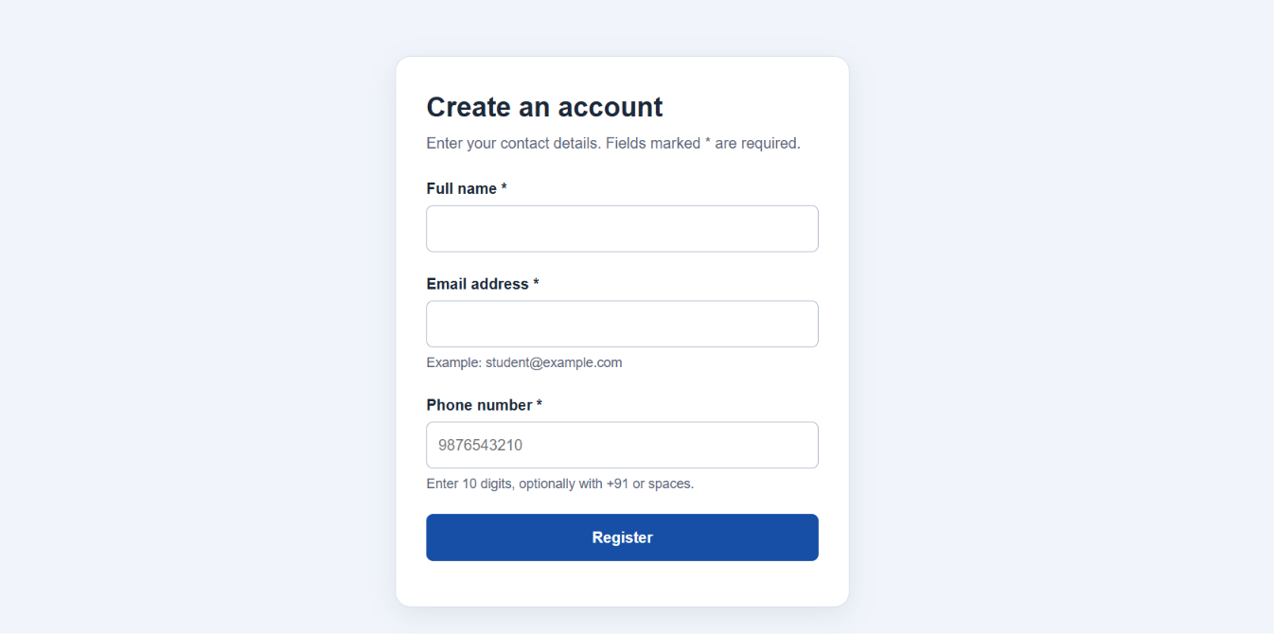

EXPERIMENT 3: CSS LAYOUT DEBUGGING
To identify causes of overlapping webpage elements, understand the CSS box model, debug layout using normal flow, Flexbox and Grid, and verify that the corrected page remains aligned when the browser window is resized.

Problem Statement
A webpage layout overlaps when the browser window is resized. Text may cover images, cards may collide, and fixed-position sections may obscure other content. The correction is to use normal document flow and responsive layout systems for the main page structure, reserving absolute positioning for contained decorative elements.

(a) CSS Properties That Can Cause Overlapping
position: absolute: Why it may overlap – Element is removed from normal flow and can cover adjacent content.; Debugging action – Use Grid/Flexbox for main sections; position relative to a deliberate parent only when needed.
Fixed width + large padding: Why it may overlap – The total width exceeds the viewport.; Debugging action – Use box-sizing:border-box; max-width:100%; flexible sizing.
Negative margins: Why it may overlap – Elements are deliberately pulled over neighbours.; Debugging action – Remove or reduce negative margins unless the overlap is intentional.
Fixed height: Why it may overlap – Text wraps to more lines but the container cannot grow.; Debugging action – Use min-height or auto height.
Large z-index: Why it may overlap – Element is painted above another element.; Debugging action – Inspect stacking contexts and reduce unnecessary z-index.
Floats without clearing: Why it may overlap – Following content may wrap around or collapse unexpectedly.; Debugging action – Use Flexbox/Grid or clear the float.
No min-width: 0 in flex/grid children: Why it may overlap – Long content forces columns wider than available space.; Debugging action – Set min-width:0 and wrap long content.
Viewport-based fixed elements: Why it may overlap – Sticky bars or banners cover content on small screens.; Debugging action – Add responsive sizing and enough content offset.

(b) CSS Box Model
Every element is represented by a rectangular box consisting of content, padding, border and margin. With the default content-box model, the declared width applies only to the content; padding and border are added to the rendered size. With border-box, the declared width includes content, padding and border.

Box Model Diagram
Outer layer: MARGIN
┌─────────────────────────────────────────────────────────────┐
│ MARGIN │
│ ┌───────────────────────────────────────────────────────┐ │
│ │ BORDER │ │
│ │ ┌─────────────────────────────────────────────────┐ │ │
│ │ │ PADDING │ │ │
│ │ │ ┌───────────────────────────────────────────┐ │ │ │
│ │ │ │ CONTENT: text / image / controls │ │ │ │
│ │ │ └───────────────────────────────────────────┘ │ │ │
│ │ └─────────────────────────────────────────────────┘ │ │
│ └───────────────────────────────────────────────────────┘ │
└─────────────────────────────────────────────────────────────┘
Example: if width is 300px, padding is 20px on each side and border is 2px on each side, content-box renders to 344px total (300 + 40 + 4). Under border-box, the outer width remains 300px and the content area becomes smaller.

(c) Positioning Techniques and Debugging Method
Normal flow (static): How it behaves – Elements appear in document order and naturally move as content grows.; Best use – Default for paragraphs, sections and page structure.
position: relative: How it behaves – Keeps its original layout space but allows visual offset; establishes a reference for absolute children.; Best use – Small adjustments or parent for a contained badge.
position: absolute: How it behaves – Removed from normal flow and positioned relative to a containing block.; Best use – Badges, icons or overlays inside a card, not primary page columns.
Flexbox: How it behaves – One-dimensional distribution in a row or column.; Best use – Header, toolbar, navigation, aligned form controls.
Grid: How it behaves – Two-dimensional rows and columns.; Best use – Product cards, dashboards and page-level columns.

Debugging workflow diagram
Inspect → Isolate → Correct → Verify
1. Reproduce at the viewport where overlap occurs.
2. Use browser Developer Tools to inspect computed width, height, margin, padding, position and z-index.
3. Temporarily disable suspicious declarations and identify the rule causing the overlap.
4. Replace fixed dimensions with flexible layout, min/max constraints and responsive breakpoints.
5. Re-test at narrow, medium and wide widths; verify keyboard and zoom behaviour.

(d) Corrected Runnable Code
Create a folder named experiment3-debugging with index.html, style.css and script.js. The intentionally problematic layout is not used as the final solution; the corrected code below demonstrates safe layout patterns.

File 1: index.html
<!DOCTYPE html>
<html lang="en">
<head>
<meta charset="UTF-8">
<meta name="viewport" content="width=device-width, initial-scale=1.0">
<title>CSS Layout Debugging Demo</title>
<link rel="stylesheet" href="style.css">
<script src="script.js" defer></script>
</head>
<body>
<header class="topbar">
<a class="logo" href="#">LayoutLab</a>
<nav aria-label="Main navigation">
<a href="#overview">Overview</a>
<a href="#cards">Cards</a>
<a href="#tips">Tips</a>
</nav>
</header>
<main class="container">
<section class="hero" id="overview">
<div class="hero-copy">
<p class="eyebrow">CSS DEBUGGING EXERCISE</p>
<h1>A layout that adapts instead of overlapping</h1>
<p>Resize the browser. The content should reflow into fewer columns
without covering other elements or creating horizontal scrolling.</p>
<a class="primary-link" href="#cards">Explore layout cards</a>
</div>
<aside class="notice">
<strong>Debugging rule</strong>
<p>Use Grid and Flexbox for the structure. Keep absolute positioning
for small, contained overlays only.</p>
</aside>
</section>
<section id="cards" aria-labelledby="cardsTitle">
<h2 id="cardsTitle">Responsive information cards</h2>
<div class="card-grid">
<article class="info-card">
<span class="number">01</span>
<h3>Flexible sizing</h3>
<p>Use minmax() and min-width: 0 so content fits its grid track.</p>
</article>
<article class="info-card">
<span class="number">02</span>
<h3>Natural height</h3>
<p>Allow text to wrap and let cards grow rather than clipping content.</p>
</article>
<article class="info-card">
<span class="number">03</span>
<h3>Consistent spacing</h3>
<p>Use gap and a shared spacing scale instead of random offsets.</p>
</article>
</div>
</section>
<section class="tips" id="tips">
<h2>Resize test checklist</h2>
<ul>
<li>No card should cover another card.</li>
<li>Text should wrap within its own container.</li>
<li>Navigation should wrap or stack on narrow screens.</li>
<li>There should be no unintended horizontal scrollbar.</li>
</ul>
<p id="viewportInfo" aria-live="polite"></p>
</section>
</main>
<footer class="footer">
<p>LayoutLab · CSS layout debugging practice</p>
</footer>
</body>
</html>

File 2: style.css
* { box-sizing: border-box; }
:root {
--ink: #182230;
--muted: #566477;
--brand: #2459a9;
--line: #d8e0eb;
--surface: #fff;
--page: #f3f6fa;
--gap: 1.25rem;
}
body {
margin: 0;
background: var(--page);
color: var(--ink);
font-family: Arial, Helvetica, sans-serif;
line-height: 1.65;
}
img { max-width: 100%; height: auto; }
a { color: inherit; }
.topbar {
display: flex;
align-items: center;
justify-content: space-between;
flex-wrap: wrap;
gap: 0.75rem 1.5rem;
padding: 1rem max(1rem, calc((100% - 1100px) / 2));
background: var(--surface);
border-bottom: 1px solid var(--line);
}
.logo { color: var(--brand); font-size: 1.35rem; font-weight: 800; text-decoration: none; }
.topbar nav { display: flex; flex-wrap: wrap; gap: 0.4rem; }
.topbar nav a { padding: 0.4rem 0.65rem; border-radius: 0.4rem; text-decoration: none; }
.topbar nav a:hover { background: #e9eff8; }
.container { width: min(100% - 2rem, 1100px); margin-inline: auto; }
.hero {
display: grid;
grid-template-columns: minmax(0, 1.7fr) minmax(220px, 1fr);
align-items: center;
gap: var(--gap);
padding-block: clamp(1.5rem, 4vw, 3rem);
}
.hero-copy, .notice, .info-card, .tips {
min-width: 0;
overflow-wrap: anywhere;
}
.eyebrow { color: var(--brand); font-weight: 800; font-size: 0.82rem; letter-spacing: 0.07em; }
h1 { max-width: 16ch; margin: 0.2rem 0 0.8rem; font-size: clamp(1.8rem, 4vw, 3rem); line-height: 1.15; }
.hero-copy p { color: var(--muted); }
.primary-link {
display: inline-block;
padding: 0.7rem 1rem;
border-radius: 0.5rem;
background: var(--brand);
color: white;
text-decoration: none;
font-weight: 700;
}
.notice {
padding: 1.25rem;
border: 1px solid var(--line);
border-left: 5px solid var(--brand);
border-radius: 0.75rem;
background: var(--surface);
}
.notice p { margin-bottom: 0; color: var(--muted); }
h2 { margin-top: 0.5rem; }
.card-grid {
display: grid;
grid-template-columns: repeat(3, minmax(0, 1fr));
gap: var(--gap);
margin-bottom: 2rem;
}
.info-card {
position: relative;
padding: 1.25rem;
border: 1px solid var(--line);
border-radius: 0.8rem;
background: var(--surface);
box-shadow: 0 3px 12px rgb(25 45 80 / 6%);
}
.info-card h3 { margin: 0.5rem 0; }
.info-card p { margin-bottom: 0; color: var(--muted); }
.number { color: var(--brand); font-size: 1.5rem; font-weight: 800; }
.tips {
margin-bottom: 2rem;
padding: 1.25rem;
border-radius: 0.75rem;
background: #e8eff9;
}
.footer { padding: 1rem; text-align: center; background: #182230; color: white; }
.footer p { margin: 0; }
:focus-visible { outline: 3px solid #d69e00; outline-offset: 3px; }
/* Tablet: the hero stacks and cards become two columns */
@media (max-width: 800px) {
.hero { grid-template-columns: minmax(0, 1fr); }
.card-grid { grid-template-columns: repeat(2, minmax(0, 1fr)); }
}
/* Mobile: one column, flexible header and comfortable touch targets */
@media (max-width: 520px) {
.topbar { align-items: flex-start; flex-direction: column; }
.topbar nav { width: 100%; }
.topbar nav a { padding: 0.55rem 0.7rem; }
.card-grid { grid-template-columns: minmax(0, 1fr); }
.container { width: min(100% - 1.25rem, 1100px); }
}
/* Respect users who request less motion if animations are added later. */
@media (prefers-reduced-motion: reduce) {
* { scroll-behavior: auto; }
}

File 3: script.js
const viewportInfo = document.getElementById("viewportInfo");
function updateViewportInfo() {
viewportInfo.textContent =
`Current viewport width: ${window.innerWidth}px. Resize the window and confirm the cards reflow.`;
}
window.addEventListener("resize", updateViewportInfo);
updateViewportInfo();

How the corrected CSS prevents overlap
box-sizing: border-box: Reason – Prevents padding and borders from unexpectedly increasing declared widths.
grid-template-columns: repeat(3, minmax(0, 1fr)): Reason – Creates equal columns that can shrink; minmax(0,1fr) avoids min-content overflow.
min-width: 0: Reason – Allows Grid/Flex children to shrink below their intrinsic content width.
overflow-wrap: anywhere: Reason – Prevents a long unbroken word from forcing the container wider.
flex-wrap: wrap: Reason – Allows navigation items to move onto another line when necessary.
clamp(): Reason – Keeps heading size fluid but within readable minimum and maximum values.
Auto height and natural document flow: Reason – Containers expand as content wraps rather than allowing text to collide.
Media queries: Reason – Switch from three columns to two and then one as space becomes limited.

(e) Evaluation and Best Practices
Desktop: 1366px: Expected outcome – Hero has two columns; three cards on one row.; Reason – Wide screen uses available space.
Tablet: 768px: Expected outcome – Hero stacks; cards use two columns.; Reason – Media query reduces layout complexity.
Mobile: 375px: Expected outcome – Single-column cards; header/navigation wrap.; Reason – Small viewport has enough room for content.
Very long heading: Expected outcome – Text wraps without pushing other elements off-screen.; Reason – max-width and overflow-wrap constrain content.
Browser zoom 200%: Expected outcome – Layout reflows and controls remain visible.; Reason – Relative sizing and responsive breakpoints.
Keyboard only: Expected outcome – Links have visible focus indicators.; Reason – Improves accessibility and usability.

Best practices
Use normal flow, Flexbox and Grid for primary layout; do not use absolute positioning to place every section.
Prefer min-height over fixed height for content panels that contain text.
Use consistent spacing variables and a shared typography scale.
Inspect computed styles and disable declarations in Developer Tools to isolate the exact cause.
Use semantic HTML landmarks and logical heading order.
Test real devices, browser zoom, orientation changes and long translated text.
Use z-index only when there is a clear stacking requirement; large z-index values do not fix poor layout structure.
Keep CSS breakpoints based on when the content becomes cramped, not only on named device models.
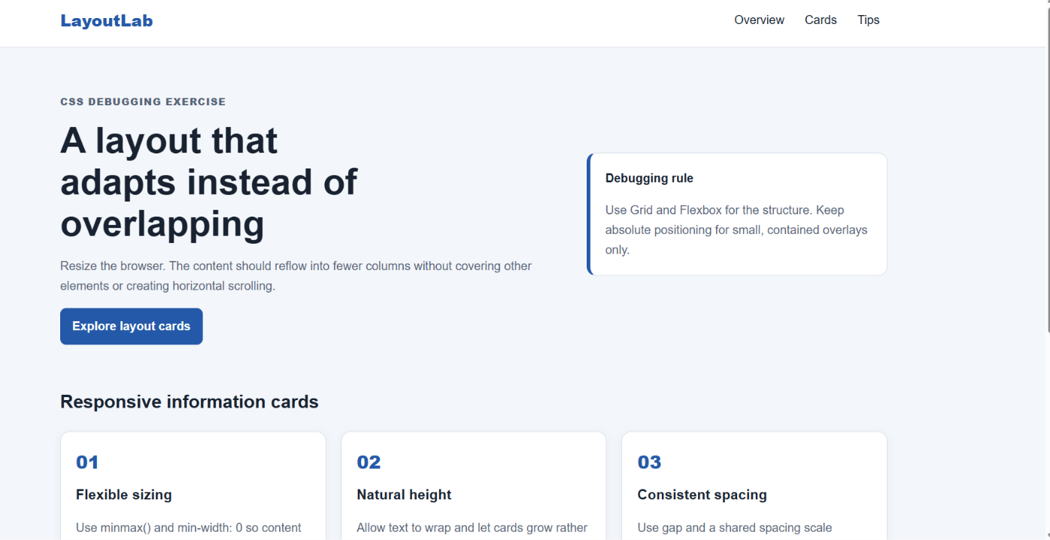

RUBRICS FOR CALCULATION:
Criteria | Weightage | Level 4 – Exemplary | Level 3 – Proficient | Level 2 – Developing | Level 1 – Beginning
Understanding of Concepts | 25 | Demonstrates thorough understanding and effectively integrates multiple concepts/technologie s | Good understanding with proper integration of most concepts | Basic understanding; limited or partial integration | Poor understanding; unable to integrate concepts
Experimental Design | 30 | Well-planned, systematic  implementation with optimal solution | Correct implementation with minor issues | Basic implementation  with errors or inefficiencies | Incorrect or incomplete implementation
Use of Tools | 20 | Effective and  advanced use of tools/technologies with proper configuration | Appropriate use of tools with correct execution | Limited or inconsistent use of tools | Incorrect or minimal use of tools
Analysis of Results | 15 | Insightful analysis with accurate interpretation and  validation of results | Good analysis with reasonable interpretation | Basic analysis with limited insights | Poor or incorrect analysis of results
Documentatio n | 10 | Clear, well-structured documentation with diagrams, code, and results | Organized documentation with necessary details | Basic documentation with missing details | Poor or incomplete documentation

